REGISTRATION FORM
J Frank Dobie
Boys Basketball camp
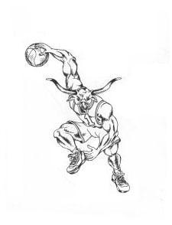

Camp will include:
- Fundamental Stations ● Ball Handling
- Games ● Various Basketball Competitions
- Strength and Conditioning ● Form Shooting

All participants will receive a
camp t-shirt

MARK YOUR CALENDAR

Monday June 13 through Thursday June 16

Time: 4:30PM to 6:30PM
Ages: Boys entering 6th grade through incoming Freshman

Registration: $50
Preferred Method - Online: http://pasadenaisd.revtrak.net

Select: DS High School All Payments, Athletics, DHS Boys Basketball Payments
Student ID is “Student” and the ID No. is “1234567”.

Enter the following in the “Comment” box: Name, Grade (Entering 2016-17), T-shirt size email address and contact number

If mailing, we can only accept – Money Orders
Please make payable to: J. Frank Dobie High School
Mail to: ATTN: Leslie Rustin – Basketball camp
10220 Blackhawk
Houston, TX 77089

Questions: Please email Coach Kevin Cross at kcross@pasadenaisd.org

PLEASE PRINT AND FILL OUT THIS FORM

Participant’s Name: ___________________________ __________________________ _______
Last Name First Name Grade (Entering 2014-15)

DOB___/____/____ Address________________________________City_______________ST_______ZIP________

Participant’s T-shirt Size (please circle one): Youth S M L Adult S M L XL

Parent/Guardian Name(s):____________________________________________

Home Phone______________________

Mobile_______________________ Email____________________________________________________

“Pasadena Independent School District does not carry insurance for summer fitness/recreation programs. Parents will be responsible for any medical expenses incurred.”

_________________________________________ ________________
Signature of Parent/Guardian Date Signed

